Theatre company visits YDA but it’s no drama for future medics.
Operating Theatre live brings real surgical dissection to Ysgol Dyffryn Aman . The event hosted on 28th March entitled Develop a Doctor was aimed to stretch and challenge sixty of the most gifted G.C.S.E. and A-level Biology students. The event successfully immersed the students into the world of medicine, on entry students were kitted out with scrubs, caps and mask and the obligatory stethoscope. They looked through mock patient files whilst being told the importance of people skills in the field of medicine, and how government are looking to push recruitment into the field of medicine. The UK is planning to open five new medical schools over the next three years in a bid to supply under-doctored areas, increase training places and keep up with the needs of an ageing population.
The programme was run by Operating Theatre Live who featured on the BBC 2 programme Dragons Den in August 2018 where it won the attention of the dragons Deborah Meaden and Peter Jones and received a £90,000 backing. 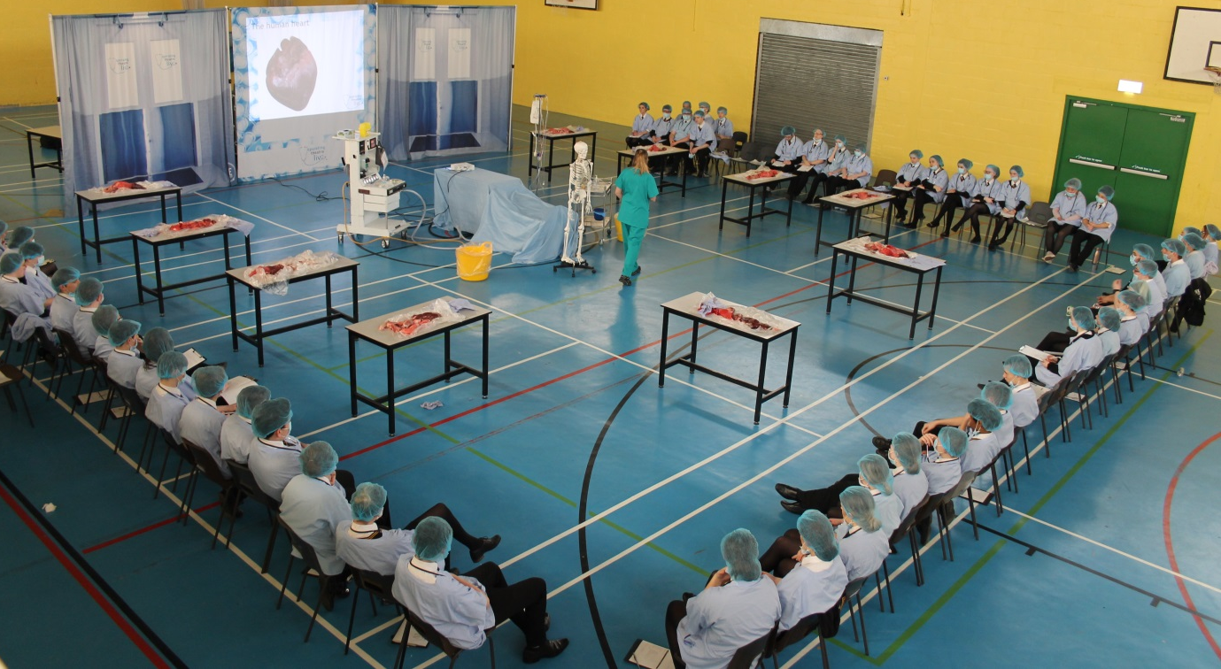

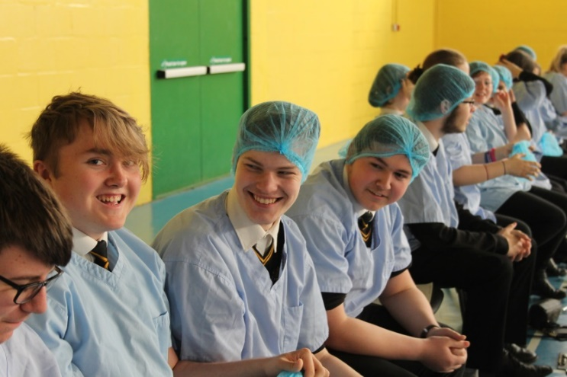
The day allowed students to practice their surgery skills and included guided dissections by trained clinicians of the brain, eye and spinal cord. Followed by guided dissection of the Circulatory Respiratory and Digestive systems. Students learnt key medical skills included calculating and administering correct doses of anaesthetic, intubation and pre surgical preparation.
The students were challenged throughout the day, gaining in-depth anatomical knowledge whilst having the opportunity to get hands on. Dyffryn Aman students impressed the staff of operating theatre who commented “It was an absolute pleasure to deliver the event to such attentive and enthusiastic students and we thoroughly enjoyed the day. Thank you for yesterday for making us feel so welcome.”
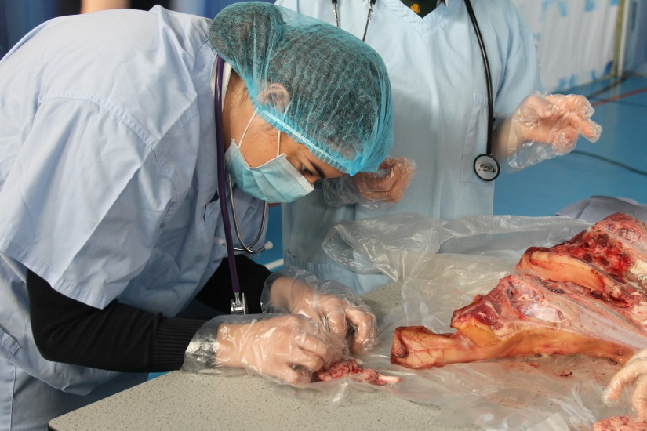

Some quotes from the students:
“Actually having the organs in front of you and dissecting them gives a much wider view on anatomy and Biology as a whole. It really conveys the complexity of the human body, although it was a pig.”
-E Dixon-Bell
“I found operating theatre live very eye opening, interesting and useful for my Biology exams now that I have been able to see everything in real life.”
E Davies
“It has given me great insight into the medical career, which I find very interesting.”
-T Cole
“Overall the experience was very enjoyable and interesting. I never realised how complex the whole organ system was. Operating theatre live gave me a real insight of how living things look and work a great experience, made me more intrigued in the medical world.”
-J Holton.
“Operating theatre live was an unusual, but it was memorable. I thoroughly enjoyed the experience and learnt a lot about the medical field. Made me think about possible careers in medicine.”
-M Sutherland

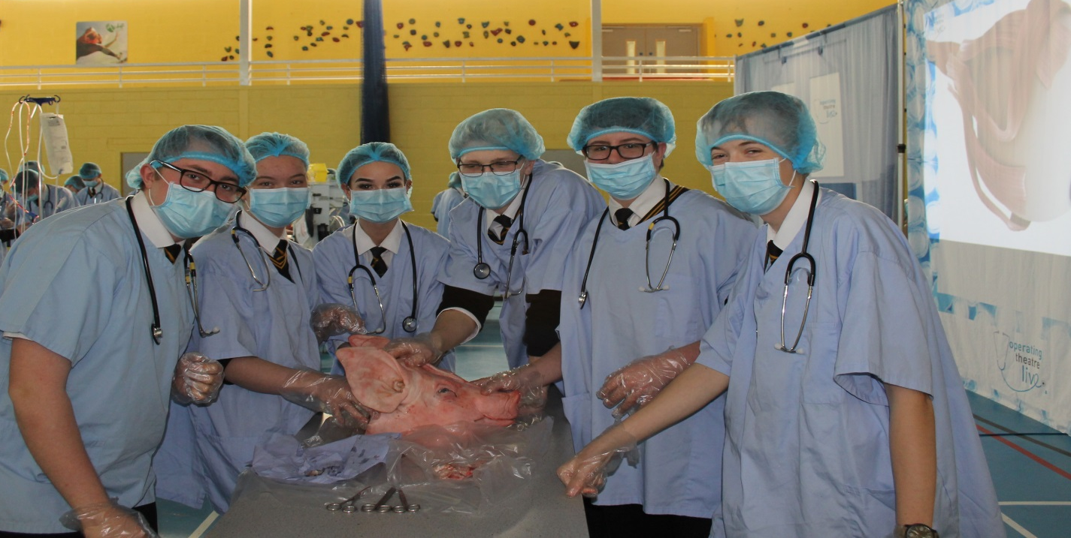
“Operating theatre live provides us with the unique expeience of dissecting multiple organs and systems of a pig. The programme was memorable and exceptionally useful, it allowed students studying A-level Biology to visualise different aspects of the body. It was a great experience!”
-C Bizby
“Enjoyed being able to see areas of the heart, eye and intestine that we have learnt about in school on a specimen. I learnt extra facts from the company that may contribute to my A- level Biology.”
-N Davies
“I thoroughly enjoyed the day and found it interesting looking at a real life brain, heart and intestines. I t will definitely help me with my A-level Biology as I learnt lot. I am so lucky to have been able to take part in it.”
-B Price
“It was interesting to have the opportunity to visualise what I have learnt throughout the biology course and to be able to apply my knowledge practically.”
-E Hancock
“Having learnt the fine details of the respiratory system and digestive system it was fascinating to see how all the different systems interact with each other seamlessly.”
-F Jenkins
The students responded amazingly to the tasks throughout the programme. Although our students typically find the fun in learning they particularly enjoyed the day. As for inspiring the Dr’s of the future tomorrow will tell. I feel confident that the experience would have given them an insight into working in the health care industry and promoted thinking about a possible career in medicine.
Mr R Finney - Teacher in Charge of Biology, Ysgol Dyffryn Aman.