Ysgol Dyffryn Aman

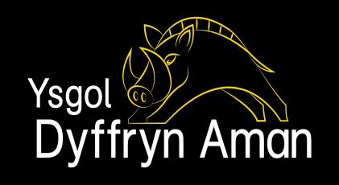

Teacher of Maths
(Permanent – Full Time)

Required by September 2021.

An exciting opportunity to join a successful Maths faculty in a large and popular school.

The governors seek to appoint an enthusiastic and knowledgeable Maths teacher to contribute to the teaching of across all keys stages. The successful applicant can expect to teach AS/A level Maths
Ysgol Dyffryn Aman is a large, popular and successful 11- 18 age group school situated in the small town of Ammanford at the foot of the Black Mountain. Pupils attending the school come from a large catchment area which is a mixture of the rural and the industrial. The school reflects the bilingual nature of the area. The ability to teach Maths through the medium of Welsh is essential.
This is a successful school which is enjoying an upward trend in the results at GCSE and the Maths department has been at the forefront of this improvement. The successful candidate will join a talented and committed team of Maths specialists.

Closing date: – Friday 26th March 2021 at Mid-day

Further details and application forms are available from:- School Website
Enquires to Admin@dyffrynaman.org

Ysgol Dyffryn Aman

Athro/Athrawes Mathemateg
(Parhaol – Llawn amser)

Ar gyfer mis Medi 2021.

Cyfle cyffrous i ymuno â chyfadran Mathemateg lwyddiannus mewn ysgol fawr a phoblogaidd.

Mae'r llywodraethwyr eisiau penodi Athro/Athrawes Mathemateg brwdfrydig a gwybodus i gyfrannu at addysgu mathemateg yng nghyfnod allweddol 3, 4 a 5. Bydd angen i’r ymgeisydd llwyddiannus addysgu Mathemateg UG / Uwch,

Mae Ysgol Dyffryn Aman yn ysgol gyfun fawr, boblogaidd a llwyddiannus i ddisgyblion 11-18 oed a leolir yn nhref fach Rhydaman ar droed y Mynydd Du. Daw disgyblion sy'n mynychu'r ysgol o dalgylch fawr sy'n gymysgedd o'r gwledig a'r diwydiannol. Mae'r ysgol yn adlewyrchu natur ddwyieithog yr ardal. Bydd yn ofynnol i’r ymgeisydd llwyddiannus ddysgu mathemateg trwy gyfrwng y Gymraeg.

Mae hon yn ysgol ddeinamig sy’n profi cynnydd ar draws ein canlyniadau TGAU ac mae'r adran fathemateg wedi bod ar flaen y gad yn y gwelliant hwn. Bydd yr ymgeisydd llwyddiannus yn ymuno â thîm talentog ac ymroddedig.

Dyddiad cau – Dydd Gwener 26ed o Fawrth 2021. 12yp

Gwybodaeth ychwanegol a ffurflenni cais i’w cael wrth:- Wefan yr Ysgol
Ymholiadau i :- admin@dyffrynaman.org

