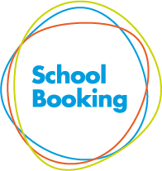
How to book an appointment

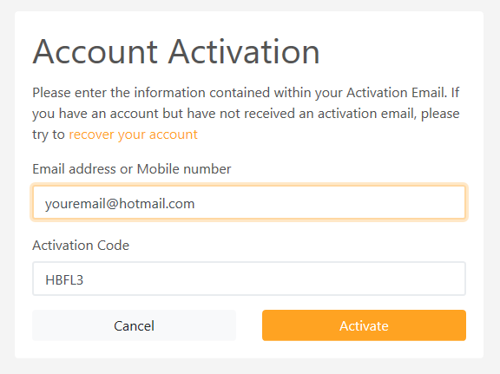
Step 1 – Activation Email & Login
Use the link provided in your activation email. This will open your browser to https://events.schoolbooking.com/ .
From here ‘Activate’ your account and setup a new password.
Saving your new password will take you directly to the Events Dashboard (Step2)

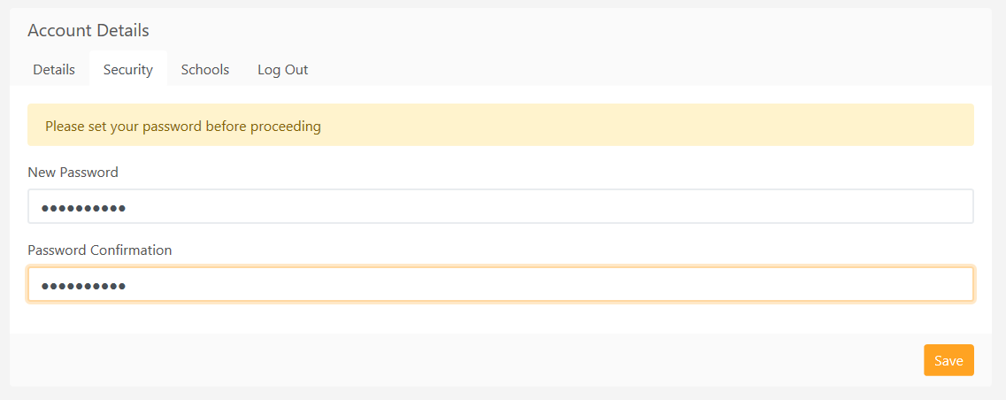

Step 2 – Select the Parent Meeting/Event
If you have children in other schools using the same system your events will be listed in order of school name.

Step 3 – Choose your how you plan to attend the Parent Meeting/Event
Use the dropdown to select the option that is best for you. Some of these choices may not be available for your event
Venue – in person at your school/education establishment – not available for our event
Telephone – the teacher will call you. – not available for our event
Video call – On-line video calls with the teacher.
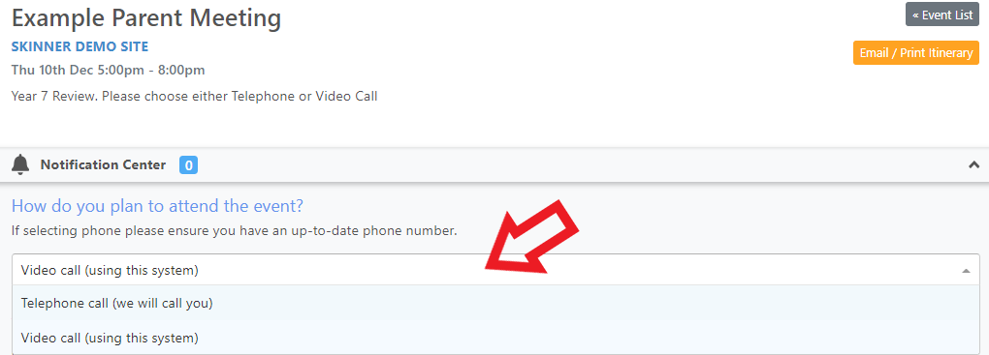
Step 4 – Choose the teachers/subjects and meeting times
Simply select the teacher/class you would like meet to view the available times, and book. If you have chosen the video calling option, you will see your unique Join Meeting links. You will need to return to this page on the day of your event to start your video calls.
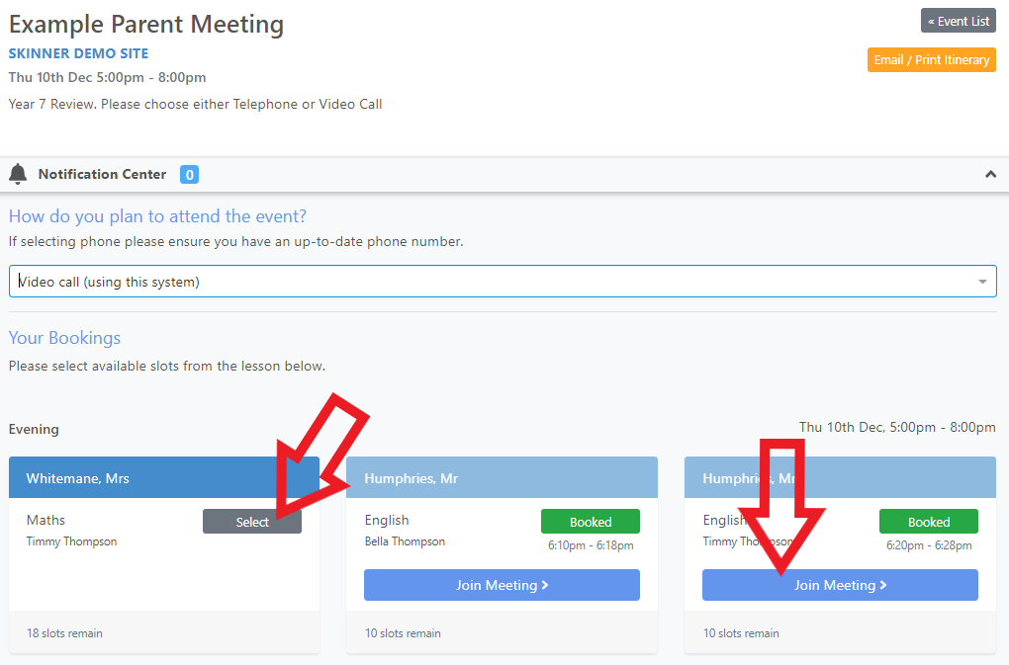

Make sure you have booked a time for every teacher you want to see and then print or email your itinerary ready to bring with you on the day.
For Video calls, please return to https://events.schoolbooking.com/ on the day of the Parent Meeting and use Join Meeting links at the appropriate time. When the teacher sees you are connected, they will join the meeting. For the best experience we recommend you use a PC or Mac (with speakers and microphone), or a mobile device such as a tablet (iOS or Android). You can use the Join Meeting links at any time to test your device settings.
You will also receive a reminder email with a copy your itinerary the day before your Parent Meeting.

Example of Printed Itinerary
